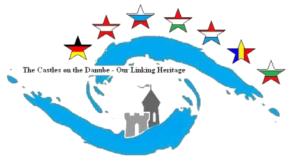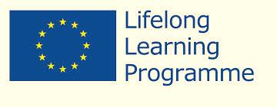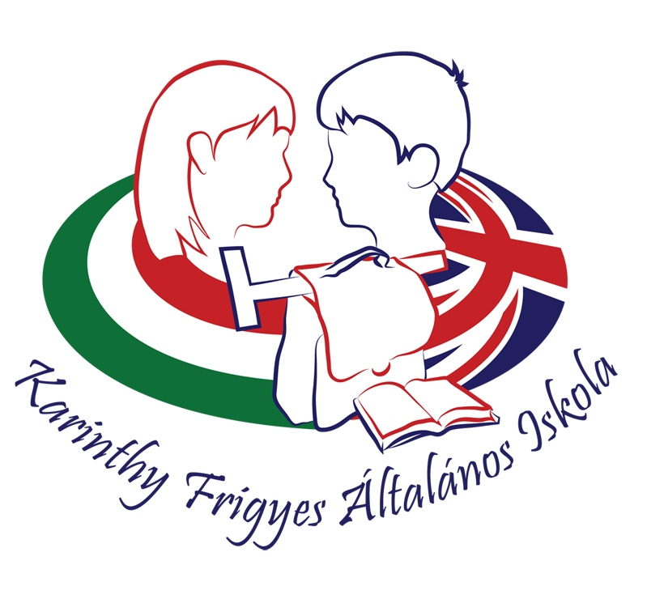

Programs and the cost

0 day 19:00 Welcome meeting at the Hotel’s dining room for the teachers
  - I sent the hotel price before
1st day, 07th April 8:00 Students come to School
9:30 Guided tour in Budapest by bus from the hotel
- Visiting the Parliament
- Buda Castle, Hero Square, City Park
15:00 Lunch at the Trófea Restaurant (All you can eat-bufet system; mails, soup, dessert, starters, non-alcohol, wine, beer, coffee..)
17:30 Boat Trip on the Danube (night light of Budapest)

2nd day: 08th April 8:00 Students come to School
9:30 Teachers arrive in the School
10:30 Opening Ceremony of Exhibition
11:15 Workshops in 7 groups by the countries
-introduce their area, making/painting their castle
12: 30 Sport activities (Joust) for the students
Meeting for the coordinator teachers
13:30 Lunch in the school
14:30 Free programs
- organized by the host parents for the students
- Cultural or any other programs for the teachers by their wish (we’ll help and guide you)
3rd day: 09th April 8:00 Students come to School
9:30 Visiting Visegrád Castle and Historical Playground by bus (bus goes to the Hotel for the teachers)
13:00 Lunch in the Forgó Restaurant, Dunabogdány at the Danube shore
15:00 Short walking in Szentendre

The bus will be provided by our school so it will be free for you.

