THE CASTLE OF ARTS
DROBETA TURNU SEVERIN
ROMANIA

Each community has its own distinct features and symbols, which define it and make it unique. The town of Drobeta Turnu Severin, settled on the north bank of the Danube river, has such a symbol in its centre - The Castle of Arts. The building, that later became a historical monument, was given to the people of Severin by the first king of the Romanians – the German Carol I.
The history of the castle started in August 1907 when, for the first time, the town supply with water from the Danube was discussed and taken into consideration. A lot of previous projects had been initiated before, regarding the town water supply, but they proved to be not enough for the needs of the community, which was in a continuous development.
Thus, on 12th January 1909 the town’s mayor received a loan of 40 000 lei (the Romanian currency) from the Public Ministry of Construction, in order to start the process of building the later castle.
The project of the town water supply has been made by the engineer Elie Radu at the Public Ministry of Construction and it consisted of 13 written pieces and 19 drawing pieces. It was approved by the Superior Technical Council and sent to the town’s mayor on 21st March 1909. The project was establishing the town supply with water from the Danube ”filtered, sterilized and cleaned with ozone”.
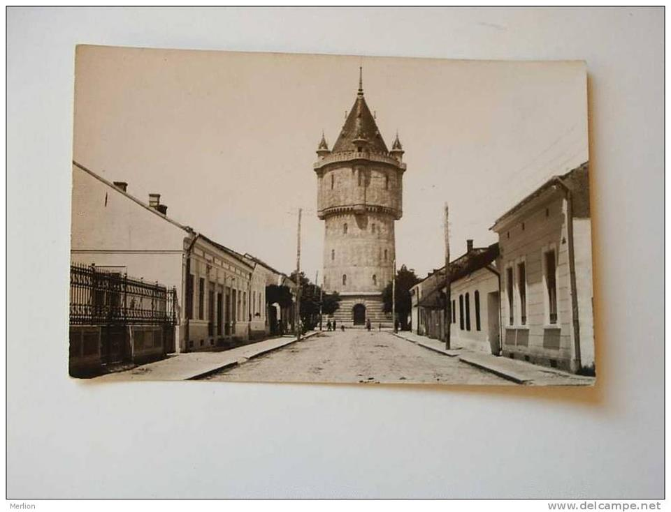
The entire set of buildings consisted of a water capture station from which the water was brought, the water plant which was going to do the cleaning, filtering and sterilizing the water and the water castle, which was supposed to distribute the water to the entire community of the town. The castle was planned to be built of reinforced concrete and inside it there were two huge water pumps that were supposed to supply the town from two sides.

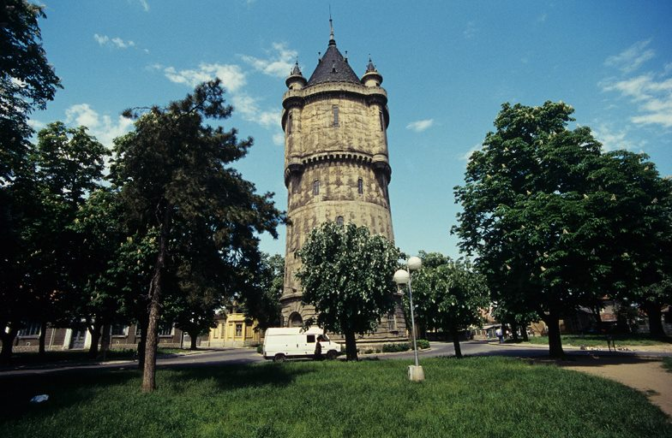

The official opening of the working site, was on 17th October 1910, in the presence of the Prime Minister I.I.C. Bratianu, of the ministers Al. Constantinescu and V. Gh. Mortun, as well as Bishop Ghenadie. The building of the castle started much more later than of the other components of the system. In March 1911, the local authorities decided to build it in the current space and this led to some negative reactions of the local community, because it was meant to be built in the centre of the town and it was going to change the whole architecture of the area.

A very strong argument against its building in the current space was the fact that there were two primary schools in that area: Primary School for Girls Number 3 and Primary School For Boys Number 3 (They are both known now as Secondary School Number 3).

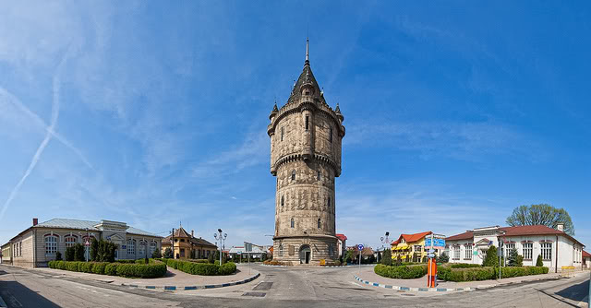
These arguments were very important, but still the plan wasn’t changed because that place was considered to be the highest point of the town and this was an advantage for distributing the water to all the other places of the town. The whole building had been generally finished by the year 1915, before the beginning of the First World War.
Nevertheless the exterior side of the castle remained unfinished and the time has laid an interesting medieval feature upon it.

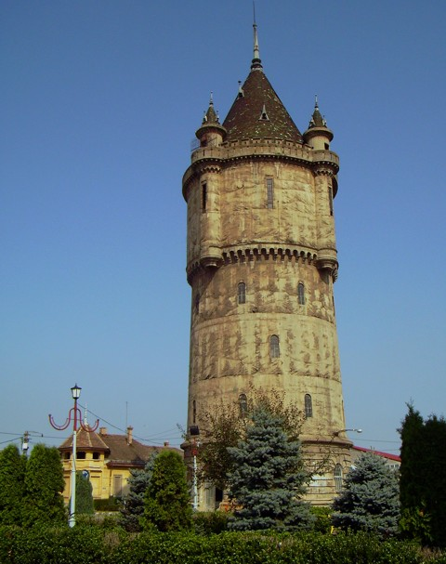
During the First World War, the castle served as an observation point for the troops and soldiers who had conquered the town.
As the town was being developed, the castle’s capacity to retain the water was not enough anymore, and the building of the third basin was brought into discussion. This basin was made in 1964 and it has been placed in the attic, over the upper concrete floor of the entire construction.

During World War II, the tower resisted heroically to all the 11 bombings from both the Germans and the Soviets and during the communism period, it was in danger of being demolished.
In 1980 The Water Castle lost its initial purpose, the basins were emptied and it started to be used as head offices and workshops for the company that used to administrate the water supply of the town. In December 2010, the town hall of Drobeta Turnu Severin has succeeded to obtain some funding for rehabilitating the Water Castle. It was reconsidered and redesigned through the project of modernizing and preserving the castle of the trans bordering cooperation program IPA Romania – Serbia.
On this occasion, its name was changed from The Water Castle to The Castle of Arts. It is considered now a heritage building and a historical monument.
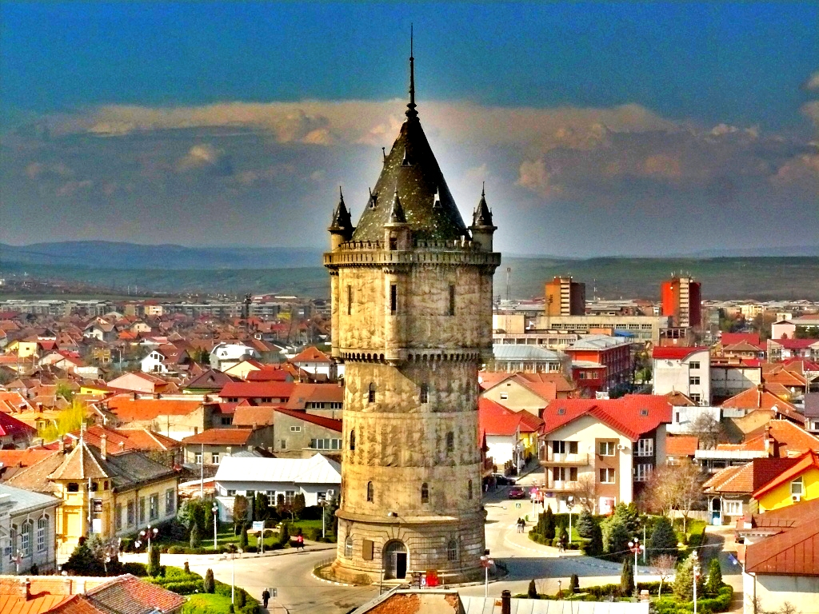
The whole building is 27 meters high and the diameter of the tower is about 10 meters. There are four little towers in its upper side. It is the first construction made of reinforced concrete in Eastern Europe.

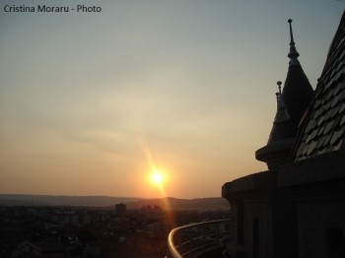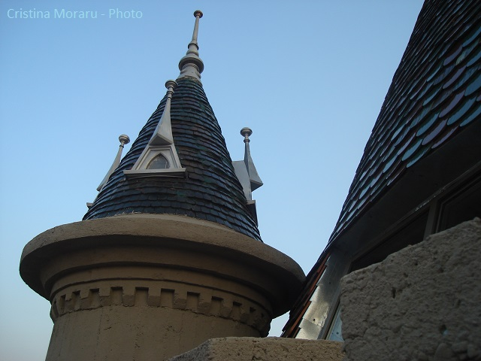

After the process of rehabilitation, the building has multiple functions and is conceived as a sequence of vertical spaces, consisting of a tourist information center, a space for exhibition art gallery, a museum “the History of water supply of Drobeta Turnu Severin town”, some photo and sculpture exhibitions, a literary café and a sightseeing place. The tourists visiting the inside of the castle have two options to reach the top of the Tower: the short way using an elevator, or the long one climbing the 400 spiral stairs.

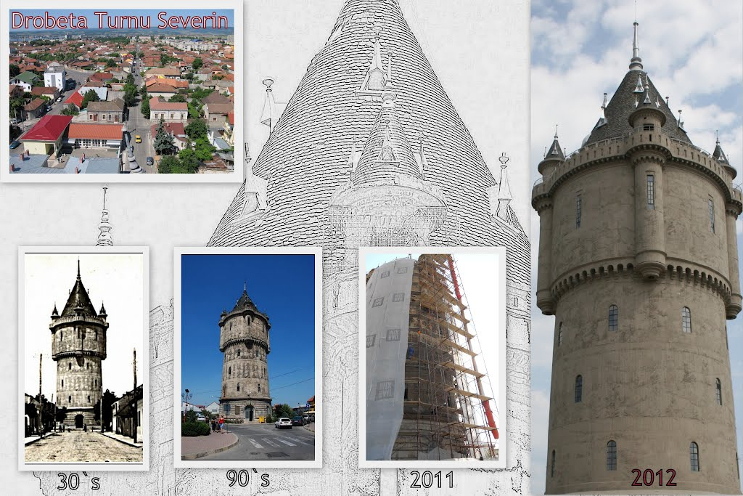

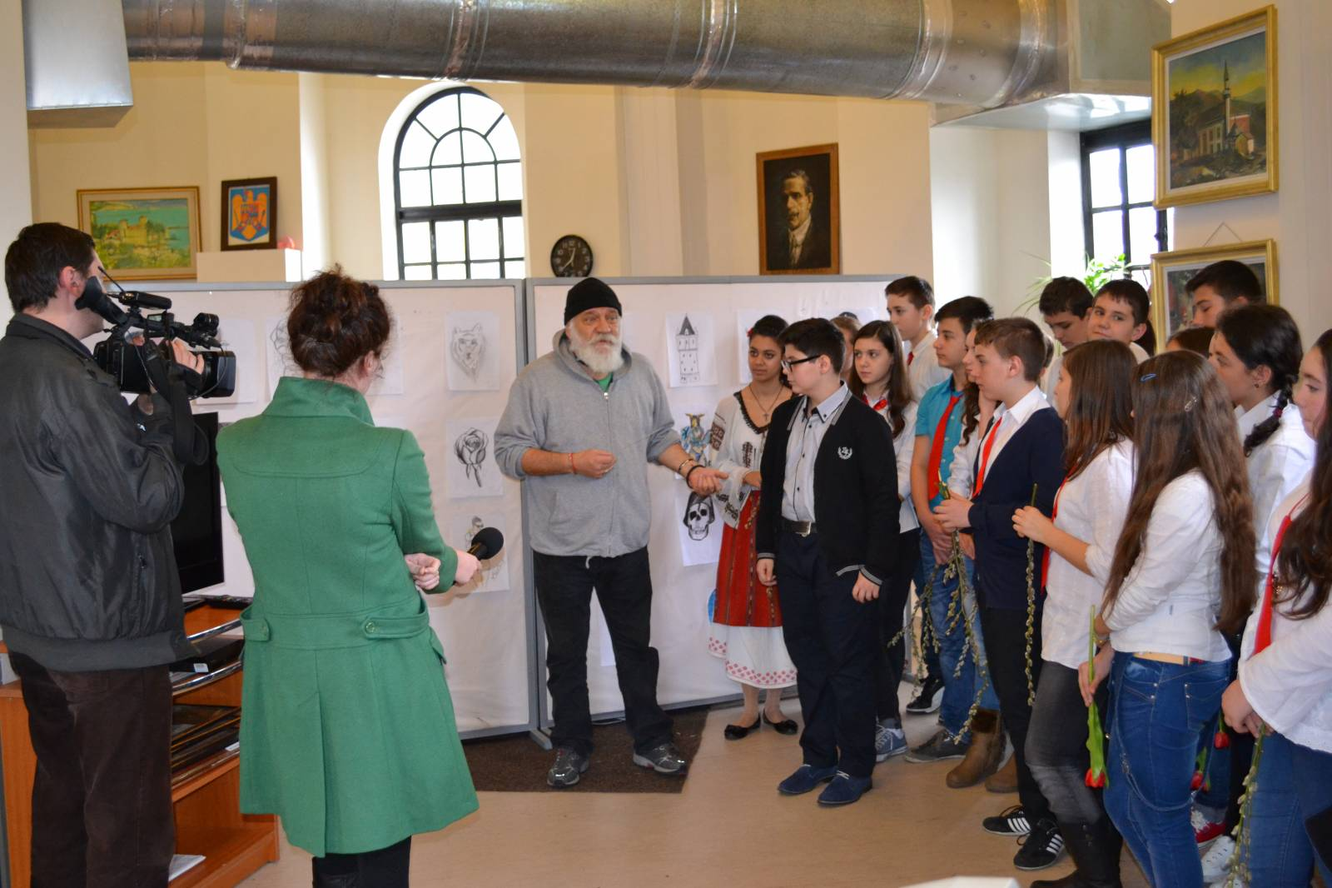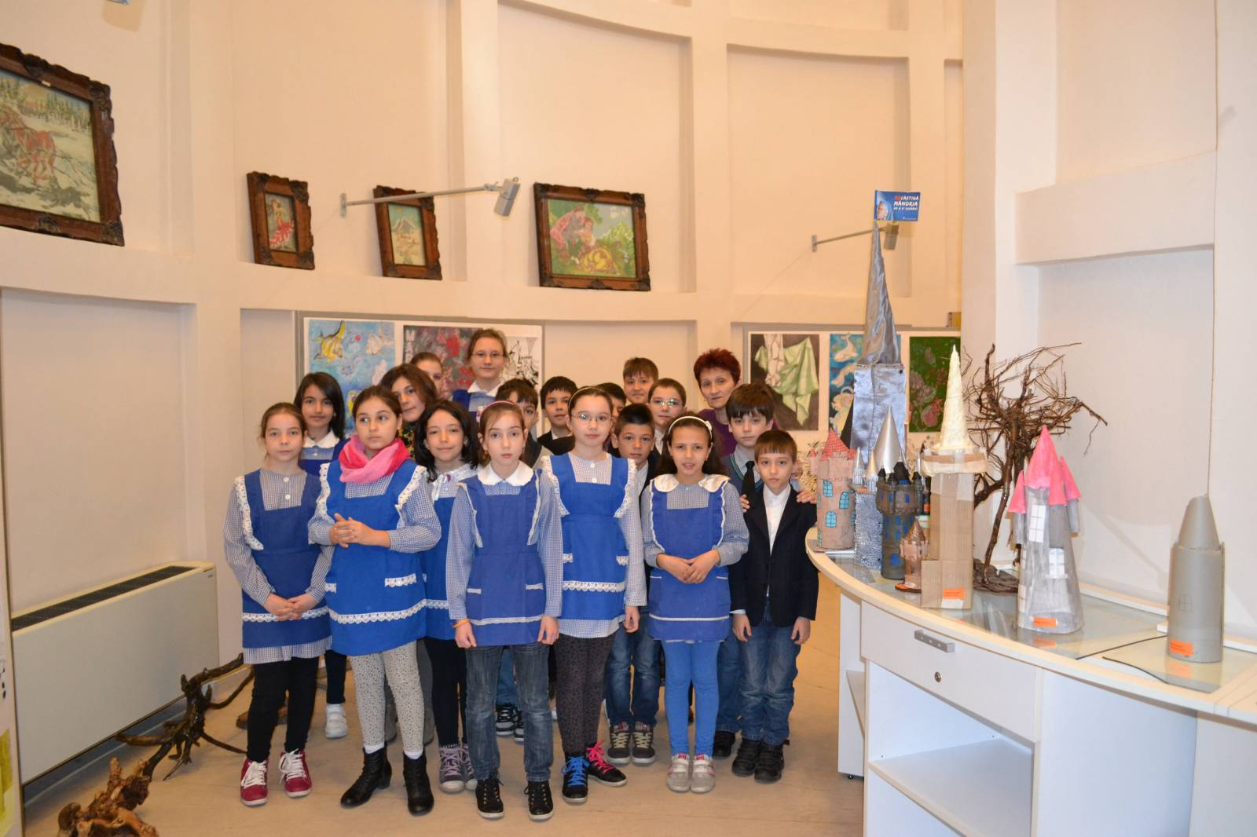

Each floor is unique in its own way. Tourists can find out about the Tower’s history, looking at the art objects which have been preserved from the period of suplying the entire town with water. Paintings, written documents, and lots of sculptures, all of them tell us about the old times, bringing them back to life.
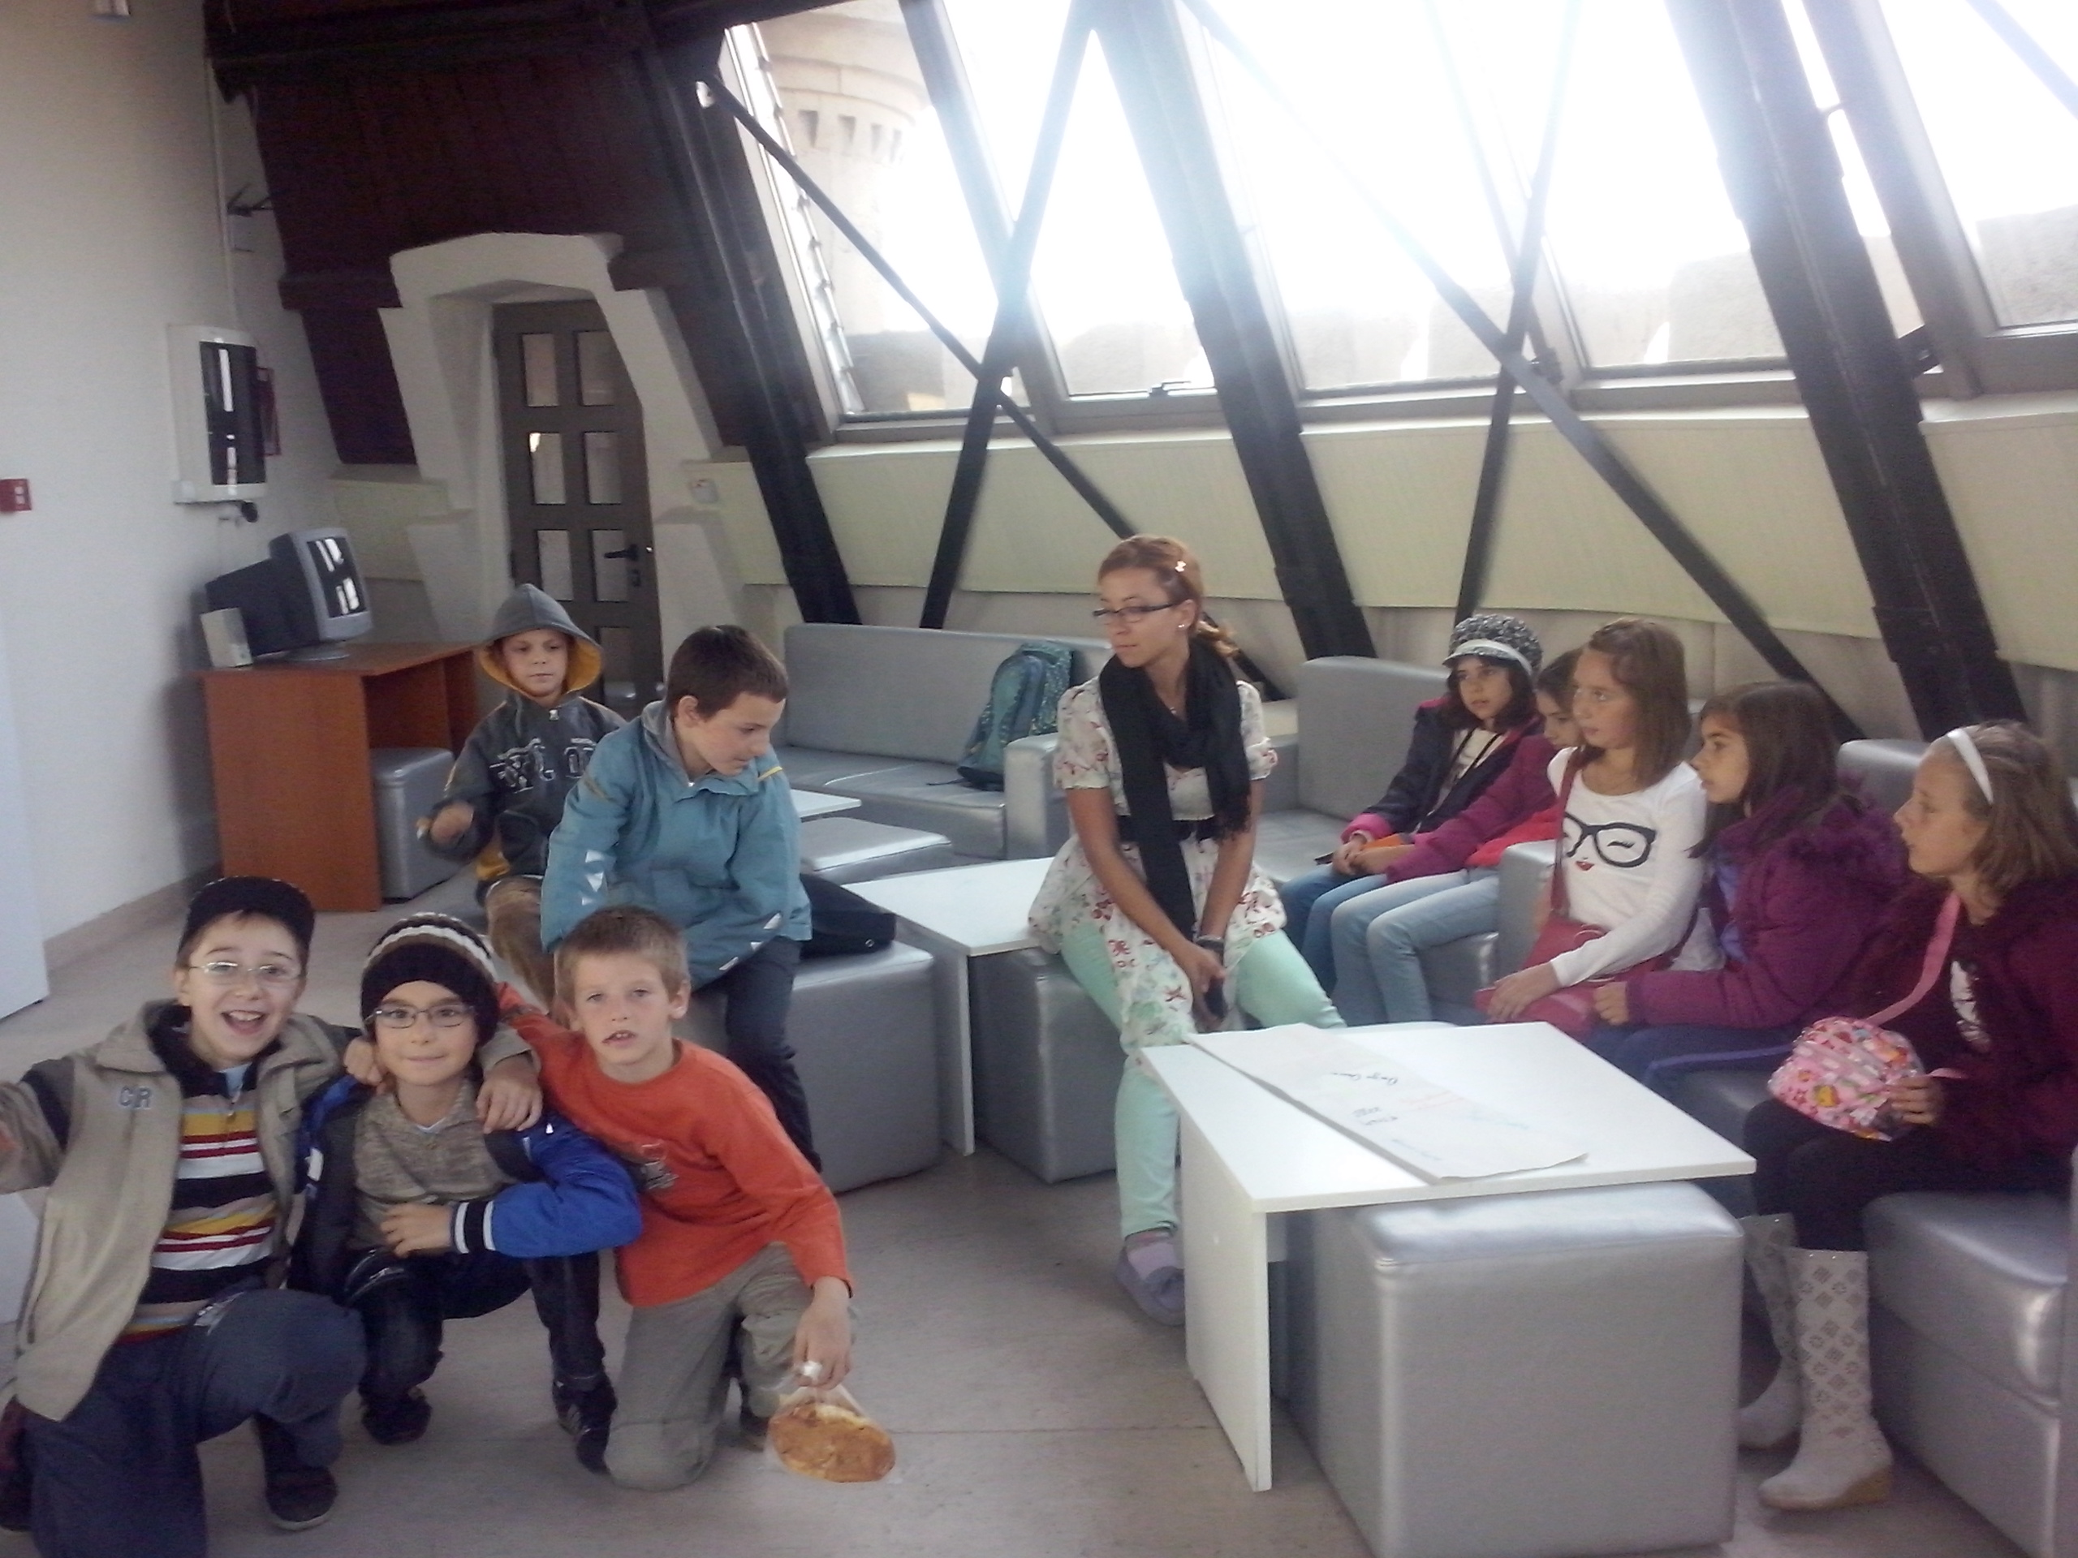

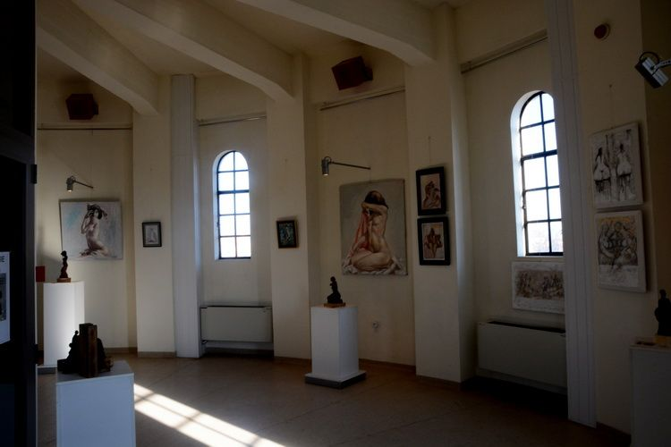
This is the reason why, the old Water Castle, now The Castle of Arts, has been introduced into the touristic circuit, being one of the most beautiful tourist attractions of Drobeta Turnu Severin. It is part of an architectural complex together with the Medieval Fortress and the Cultural Palace „Theodor Costescu”.
Theodor Costescu, director of the famous "Traian" high-school in the city, having been elected president of the "Theater of Turnu Severin" society, managed in just a few days to cover the entire bond subscription necessary to finish the construction of the theater. Work on the site began in 1912.

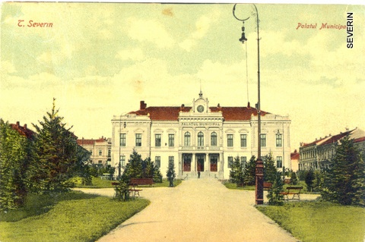
The 1916 events found the building still unfinished, but covered. After Romania reunited with Transylvania, Theodor Costescu resumed what war interrupted for him. However, the task proved to be nearly impossible, as the society did not have any funds. Hardship however could not stop the great man, endowed with an extraordinary work capacity, perseverance and endless energy.
In less than two months, at Costescu’s heated request, a few million lei are collected from both rich Severinans and less wealthy citizens. Former students of his were the first to contribute. The government and the National Bank also provided funds.

The first cornerstone of "Theodor Costescu" Cultural Palace was laid in 1912 instead of a conference and show room, like it was initially designed. It was thus able to begin its fruitful activity in 1924 and shortly managed to bring new life to the city and the county. The Cultural Palace, owned by the "heater of Turnu Severin Cultural Society, was not and could not have been the work of one single individual or of any organization, many people from Severin and Mehedinti county contributed, regardless of wealth, social position or faith.
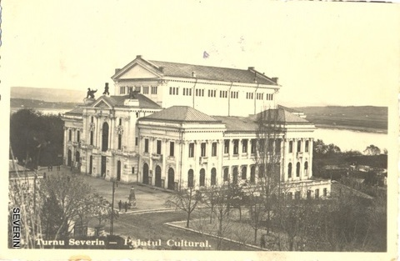

All governments also contributed, according to possibilities, as did the County Hall and the City Hall. November 30th 1924 was a very happy day. The important building – partially finished – was officially opened in the presence of Romanians come from all over the country and from aboard, where this young institution began opening village libraries, increasing the culture.
The great edifice was designed by architect Grigore Cerchez to include seven large halls, three overlapped halls to serve as the I. G. Bibicescu library, a cinema hall and a restaurant - all these forming the North win; three similar halls forming the West wing where "Dr. C.I. Istrati Museum" is housed, a festivity hall and an auxiliary hall, the seventh hall inbetween the ones mentioned was finished later and turned into a theater hall
.

"I. G. Bibicescu" Library was installed in 1925 as a donation from the great son of Mehedinti county, Ion I.G. Bibicescu, also former governor of the National Bank. A large hall and three smaller ones housed artistic armoires filled with books collected during the lifetime of the donator, the son of a Cerneti village peasant. The collection included 40000 volumes in 19 catalogues, divided on categories.
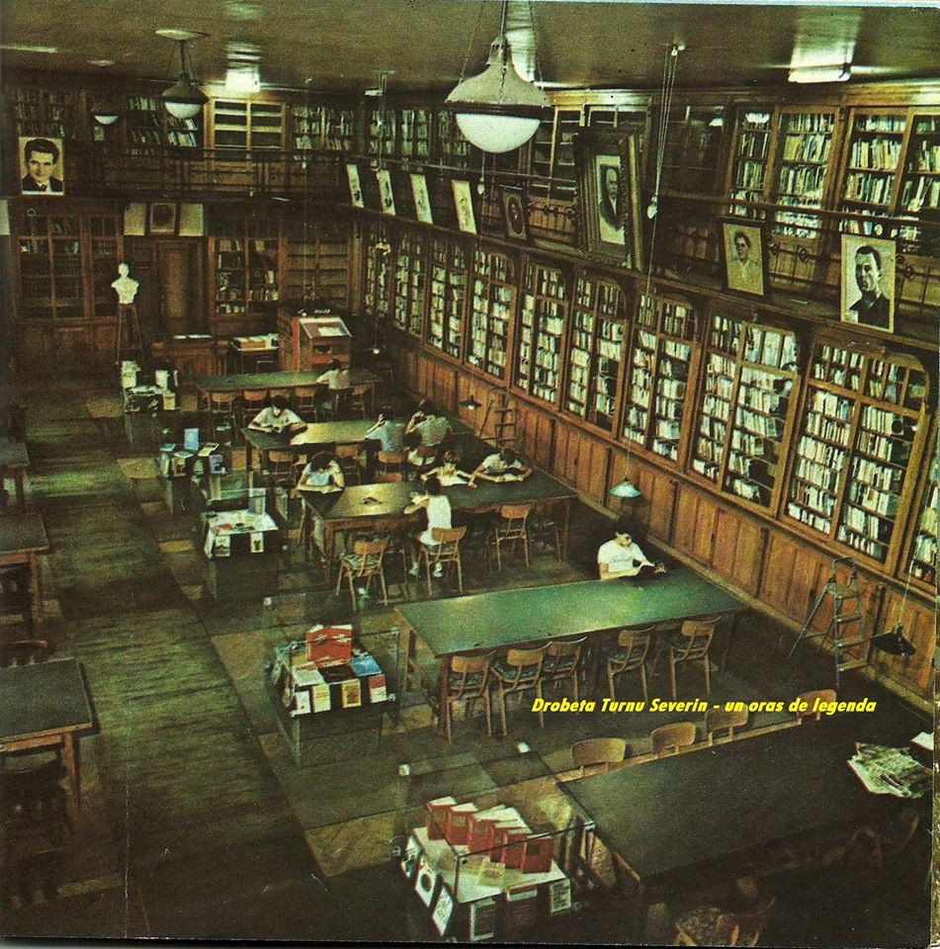

The Cinema Hall was initially meant to serve as a source of income for the society, in order to cover the costs of administration and maintenance of this great edifice. It was officially opened on October 15th 1924 with „The Gypsy Woman from the Maid Chamber". A number of special motion pictures was soon acquired. The hall has a seating capacity of 450 and a large stage that also housed plays while the proper theater hall was being built.
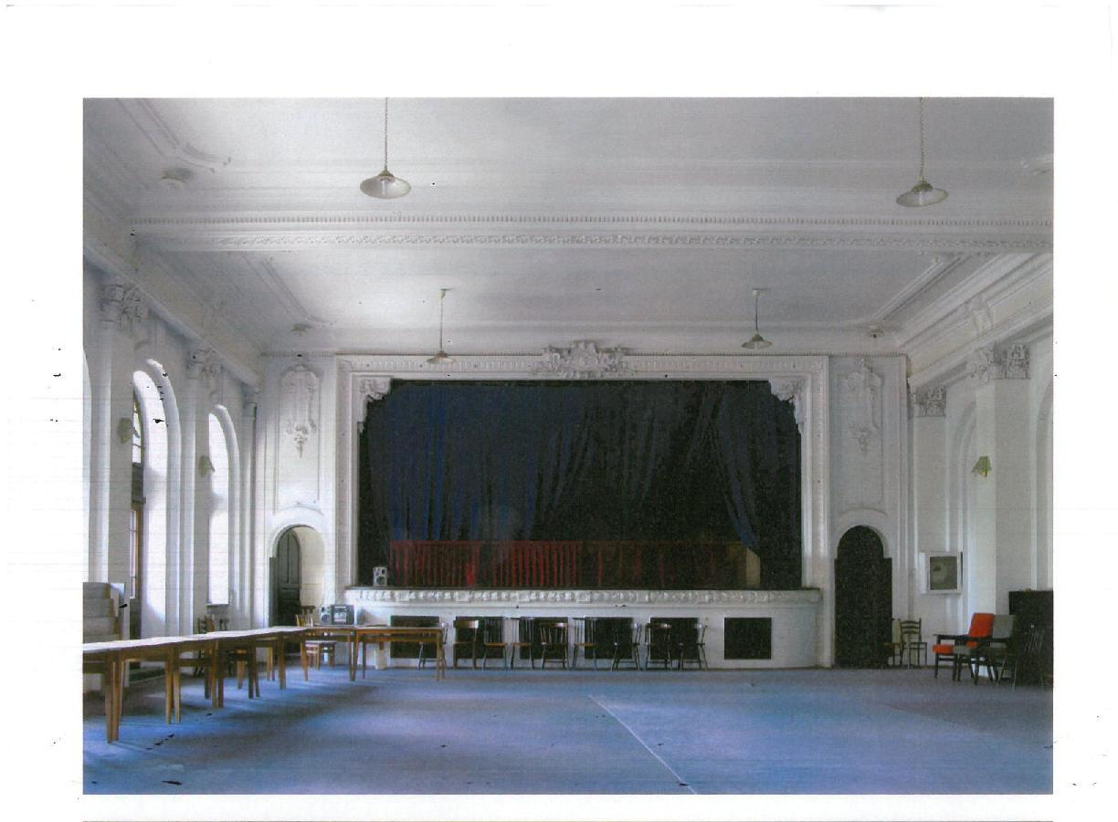

The Popular University was also held in the cinema hall, each Saturday at 16.30 hours. Also on November 30th 1924 the first cycle of conferences was held by N.N. Saveanu – the Surgeon General.

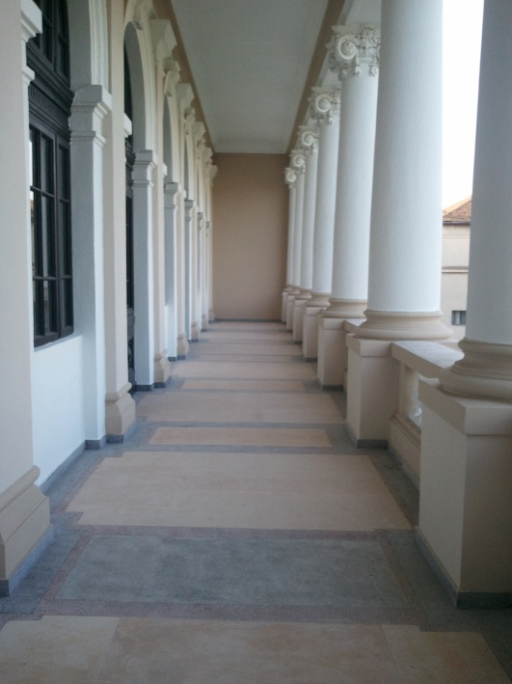
"Dr. C.I. Istrati" Museum was located on the first floor of the wonderful "Rose Park". It was a general museum of Wallachia (The Old Kingdom) and through the richness of its collections it became the great love that dr. C.I. Istrati had for our country and people. He daily collected all objects, small and large, spending his entire fortune to improve the museum with a passion that cannot be put into words.
The museum was officially opened in Câmpina in 1897. It was also shown during the exhibition from Carol I Park in 1906, also organized by the great dr. C.I. Istrati as Government Commisar.

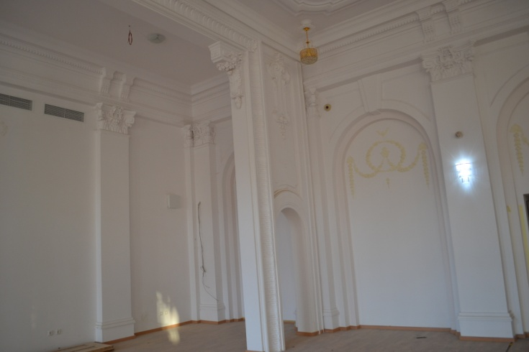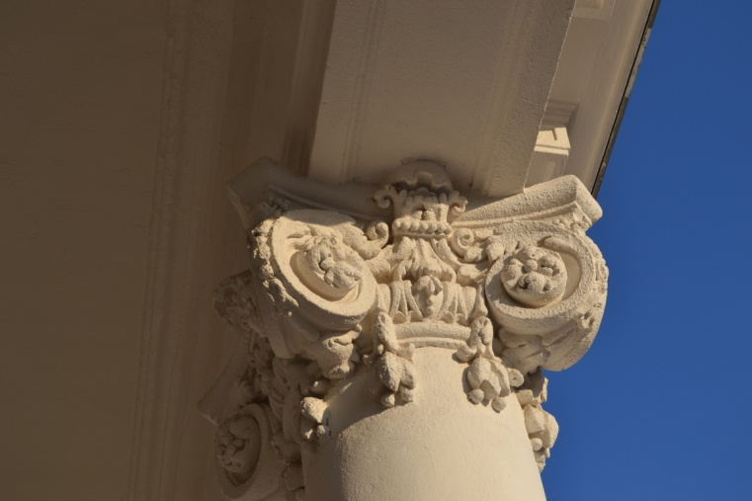

In 1924 however when the edifice that was inaugurated the great hall was not finished. Costescu called for a desperate measure: he auctioned off his entire fortune. The roof of the theater was riddled with bullet holes and there was not led to be found to repair it. Costescu removed the roofs from his own buildings to repair the theater’s.
Seeing the existence of the young cultural institution was in danger – the income was not covering even the interest rate of the loan – the benefactor underwent another sacrifice, selling part of his domain at Vanjulet. Old and ill he was becoming unable to see his dream realized. To finish the theater hall - with a seating capacity of 700, with lodges and balconies and a unique rotating stage – he made a painful decision: to sell his home in Severin.
The Ministry of Culture and Arts offered this museum to the "Prince Carol" Cultural Foundation, to the Romanian Academy and to the Museum of Antiques. However none of these institutions desired to purchase it, thus it remained exposed to the elements. Theodor Costescu, the president of the "Theater of Severin" Cultural Society, turned in a memo to the Minister, describing the terrible condition of the museum and asked for it to be returned to Turnu Severin, with the obligation to display it in the large halls of the Cultural Palace. His request was successful and on March 16th 1923 the Ministry of Culture and Arts conveyed the approval of the transfer. The museum was hurriedly installed in the Cultural Palace on November 30th 1924.

The Festivity Hall is located in the West wing of the Cultural Palace having a large terrace with a wonderful view. This was the only hall (except that of the Military Convention) where the intellectual community of Severin would gather at balls and festivities.

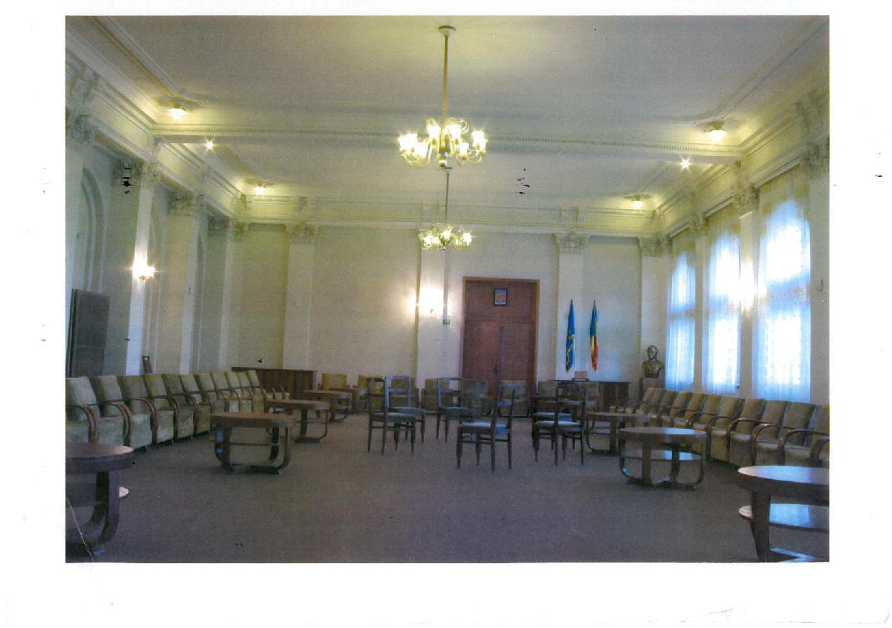

Beginning with 2012 the whole building is in renovation and today the image of The Cultural Palace Theodor Costescu is completely changed.

